Dear Prime Minister,

I am writing to request your immediate intervention on a policy decision that risks damaging the UK's fresh produce supply, increasing food inflation and imposing unnecessary new costs on businesses and consumers.

The Government's current approach to UK-EU SPS alignment risks imposing EU-style controls on Rest of World fresh produce imports destined solely for UK domestic consumption. While we broadly support the UK-EU Reset, a minor adjustment within the scope of the agreed terms would secure a solution that promotes both European and international trade seamlessly.

In terms of fresh produce your current proposal is unnecessary, disproportionate and will impose long term damage to a key food sector and consumers.

Around half of the fresh produce imported into the UK comes from countries outside the EU. These supply chains deliver the citrus, mangoes, blueberries, sweet potatoes, peppers and many other products that British consumers rely upon every day. These are not optional extras; they are essential to feeding the nation.

The UK already operates a proven, science-based and risk-led SPS regime for Rest of World fresh produce. It works! Current supply chains achieve 99.5% compliance across approximately 120,000 consignments each year.

Importantly, the Government's own scientific assessment following Brexit did not require the EU-style controls now being proposed. The science has not changed. The politics have.

If implemented, the proposed approach will result in:
• Significantly increased inspection rates on certain Rest of World fresh produce imports;
• Additional phytosanitary certification requirements;
• Expanded pre-notification and reporting obligations;
• Increased physical inspections and operational delays;
• Higher costs for highly perishable products;
• More waste, disruption and reduced supply chain resilience; and
• An estimated additional cost exceeding £300 million for the UK fresh produce sector.

These costs will not disappear. They will be passed through the supply chain and ultimately borne by UK consumers.

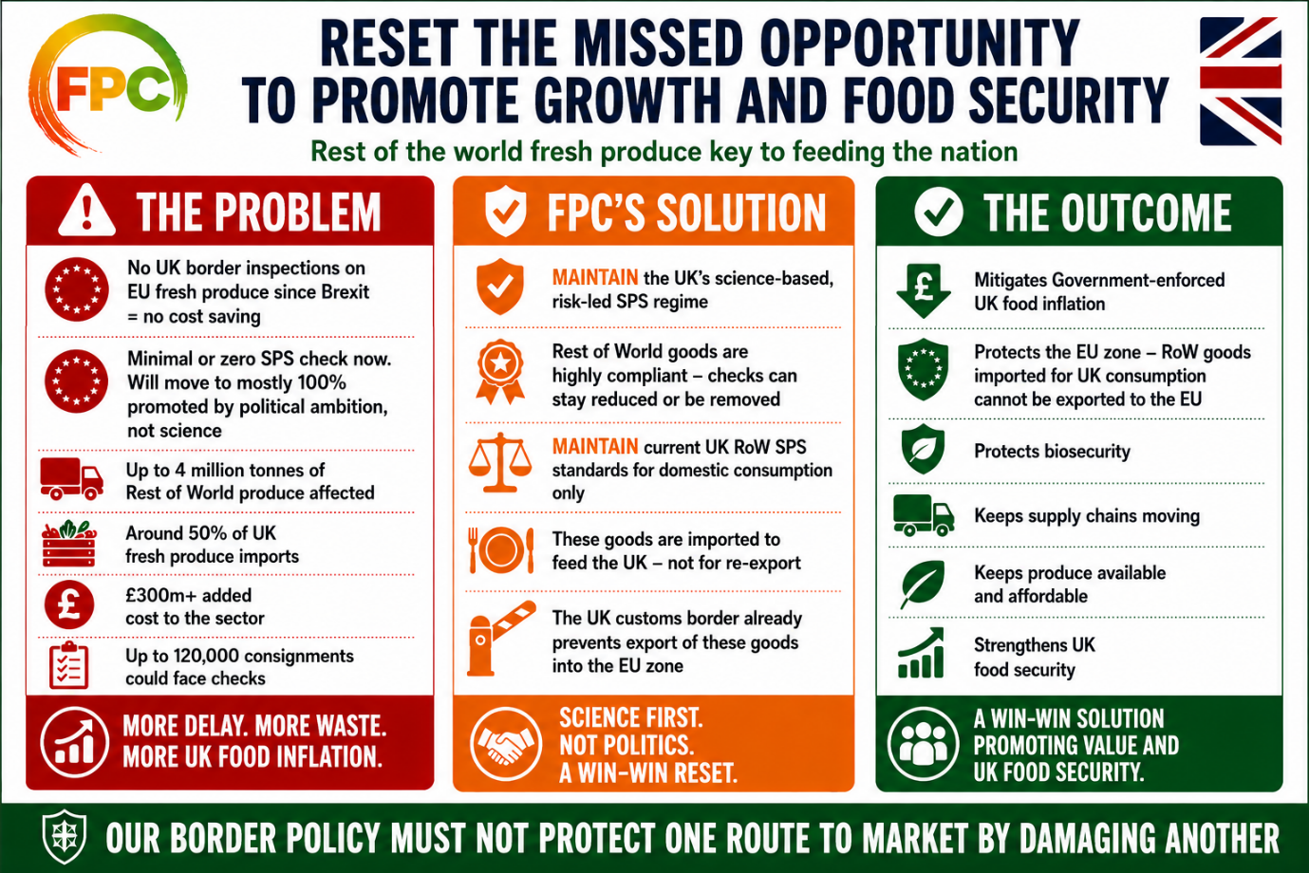

At a time when the Government is rightly focused on food security, healthy eating and the cost of living, it makes little sense to introduce avoidable border costs that will make fresh fruit and vegetables more expensive and less accessible.

The UK cannot rely solely on domestic production and EU supply. British growers are vital, but they cannot provide the full range, volume and year-round availability of fresh produce that the country requires. A credible food security strategy must support British production, facilitate UK-EU trade and maintain trusted global supply chains.

This is why the Fresh Produce Consortium has repeatedly and proactively put forward a practical win-win solution.

We are asking the Government to maintain the UK's current science-based, risk-led SPS regime for Rest of World fresh produce imported for UK domestic consumption only, while continuing to pursue improved arrangements with the EU.

• It protects UK biosecurity.
• It supports UK-EU trade.
• It avoids unnecessary inflation.
• It safeguards global fresh produce supply.
• It protects consumers.

What must not happen is for the Government to solve one trade issue with the EU by creating a much larger food security and cost challenge for the UK.

We are therefore asking you to instruct Defra and the relevant departments to engage formally with the Fresh Produce Consortium on the solutions we have already submitted before further policy decisions are finalised.

The fresh produce industry is not asking the Government to lower standards. We are asking it to apply evidence, proportionality and common sense.

The current UK regime is science-based, risk-led and highly compliant. Replacing it with an EU-style system for Rest of World imports destined solely for UK consumers will add cost, delay and complexity without delivering any meaningful benefit.

Prime Minister, this decision matters.

• It will affect food prices.
• It will affect product availability.
• It will affect consumer choice.
• It will affect the resilience of the UK's fresh produce supply chain.

This approach would also protect the wider EU SPS zone, as the UK's customs border already prevents goods imported solely for domestic UK consumption from being exported into the EU SPS area.

The Government still has an opportunity to improve this agreement. We urge you to take it.

I would welcome urgent engagement with you and your officials to ensure that the UK advances your growth and trade agenda without fundamentally compromising the global fresh produce supply chains that are essential to feeding our nation.

Yours sincerely,

ATTACH ALL THE FILES WE DISCUSSED.

